**1.1 Personal Identity | Self Image**

**Reflection Activity (1.1 RA W1)**

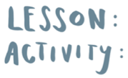

© Real Talk International Ltd.

Used under license.