**2.2 Media & Technology | Cyber Safety**

**Learning Point 1 Quiz (2.2 LP1 W1)**

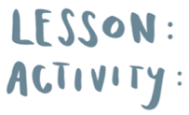

© Real Talk International Ltd.

Used under license.