**3.2 Relationships | Consent & Respect**

**Reflection Activity (3.2 RA W1)**

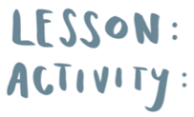

© Real Talk International Ltd.

Used under license.